Assignment - 4

|  |  |
| --- | --- |
| Student Name | RAJESH C R |
| Student Roll Number | 73771914156 |

# Question-1:

Pull an Image from docker hub and run it in docker playground.

# Solution:

* Pull an image uifd/ui-for-docker from the docker hub
* This image is used for viewing and managing the docker engine
* Use docker pull image_name and docker run -it image_name commands to
* run the above image in the Docker Playground

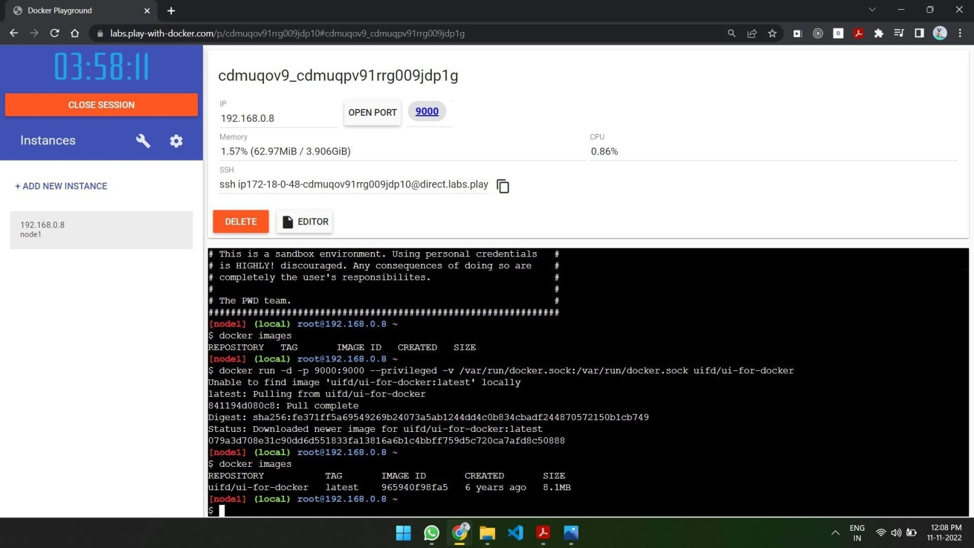

# Question-2

Create a docker file for the jobportal application and deploy it in Docker desktop application.

# Solution:

* Create a docker file for build and deploy flask app.
* Use docker build -t image_name . in the current directory to start building the
* docker image and deploy in our local docker
* Use docker run -p 5000:5000 image_name to run in local system

# CODE

FROM ubuntu/apache2 FROM python

COPY ./requirements.txt /flaskApp/requirements.txt WORKDIR /flaskApp

RUN pip install -r requirements.txt COPY . /flaskApp

ENTRYPOINT [ "python" ] CMD ["app.py" ]

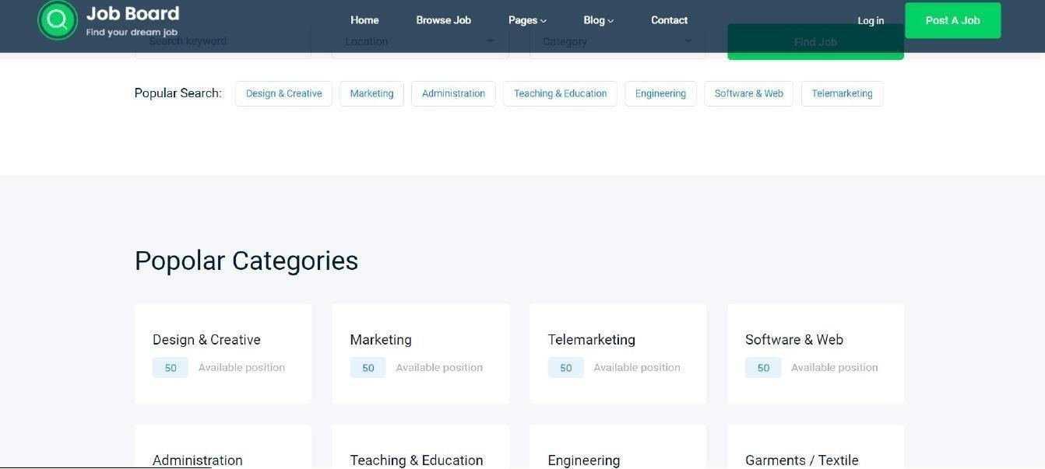

# Question-3:

Create a IBM container registry and deploy hello world app or job portal app.

# Solution:

* Log into IBM cloud
* Create a container registry
* Using IBM Cloud CLI, install the container registry plugin in our system
* Push our docker image into the created container registry using docker push
* So, our job portal app is deployed in the IBM container registry

•

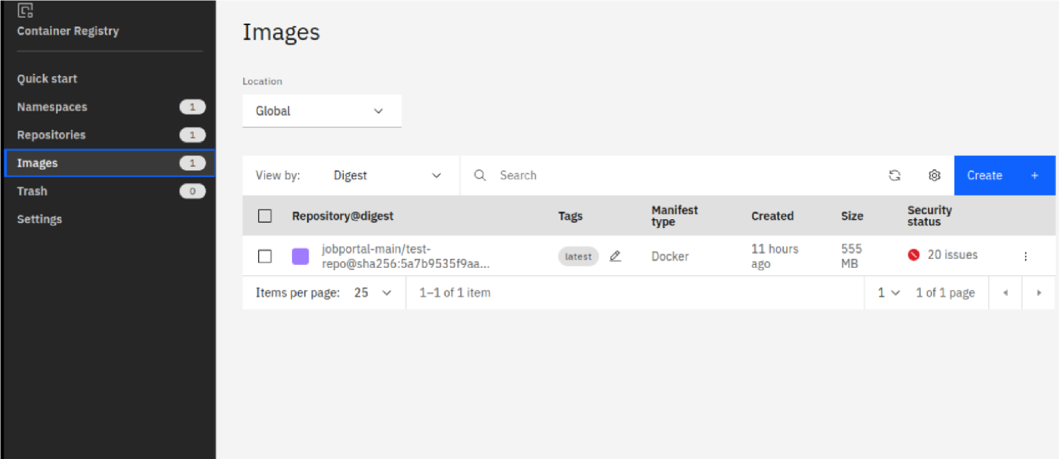

OUTPUT: “HELLO WORLD”



# Question-4:

Create a Kubernetes cluster in IBM cloud and deploy helloworld image or jobportal image and also expose the same app to run in nodeport.

# Solution:

* Log into IBM cloud
* Create a kubernete
* Using IBM Cloud CLI, install the ks plugin in our system
* Create a cluster in the kubernetes
* Now, go to the kubernetes dashboard where we need to create a service based on a
* yml file (given below)
* In that file, we have to mention which image we are going to use and the app name
* Take the public IP address and Nodeport since we exposed the flask app in nodeport
* Finally, we got the url address where our flask app is hosted CODE:

apiVersion: v1 kind:

Service metadata:

name: job-portal-app spec:

selector:

app: job-portal-app ports: - port: 5000 type: NodePort

---

apiVersion: apps/v1 kind:

Deployment metadata:

name: job-portal-app labels: app: job-portal-app

spec: selector: matchLabels: app:

job-portal-app replicas: 1 template:

metadata: labels:

app: job-portal-app spec: containers:

* name: job-portal-app image: image_name ports:
* containerPort: 5000 env:
* name:

DISABLE_WEB_APPvalue: "false"

